
St James’ Church, Weybridge
Church Lane, Weybridge, Surrey, KT13 8DN
Telephone: 01932 856399
Charity No: 1130714. www.stjamesweybridge.org.uk
Email: info@stjamesweybridge.org.uk
Rector: The Revd. Father Damian Harrison-Miles, BTh.

Rector: The Revd. Father Damian Harrison-Miles, BTh.

Information Pack for the Director of Music Role for
St James’ Church Weybridge

Introduction
Due to the retirement of our long-serving Director of Music, we now invite applications for a new Director of Music.

We are looking for a passionate and skilled musician to lead and enable Christian worship in a variety of styles, continuing our rich musical tradition and developing our musical life in a missional way. The successful candidate will work collaboratively with clergy and others to oversee all aspects of the musical life in the parish. They will play the organ, or piano where appropriate, at regular worship services and festivals and will lead the choir. We are looking for someone who can lead others, build on existing relationships, and develop new ideas. We seek someone who can work with children, young people, and adults of all ages, and can inspire others on their faith journey through music.

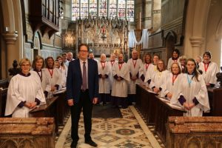

Background
The parish of Weybridge is in the Diocese of Guildford and the Emly Deanery which comprises 13 churches. Weybridge is approximately 27 miles southwest of Central London and forms part of the borough of Elmbridge in Surrey. Its name derives from a crossing point of the River Wey which flows into the River Thames to the north of the town centre and records trace the parish back to the Domesday Book.
The town has a population of approximately 15,000 and is regarded as one of the more affluent areas of Surrey. However, there are pockets of deprivation and a growing minority ethnic population. Although Weybridge is largely home to middle-class professionals, many of whom commute to London, it also has significant numbers of younger families and an increasing elderly population.
Weybridge has a mix of independent shops and the more familiar national, and chain shops one would expect in a traditional High Street. It has two supermarkets in the town centre and a further three larger stores in the nearby Brooklands retail estate. Weybridge is well served by many good restaurants and local hostelries which are popular with both locals and visitors alike.

St James’ Church, a grade II* listed building designed by the architect John Loughborough Pearson in the early English gothic revival style, was built in 1848 to replace an earlier much smaller Saxon church on the same site. Our tower and spire at 150 metres tall ensures the church occupies a pre-eminent position at the heart of Weybridge Town Centre and the installation of floodlighting has made the spire a landmark by night as well as day. St James’ Church has the affectionate title, ‘Cathedral of the Thames Valley’.
The church has a ring of 8 bells, given in 1874 by the Roberts family in memory of their father, which were rehung on a new steel frame in 1989.
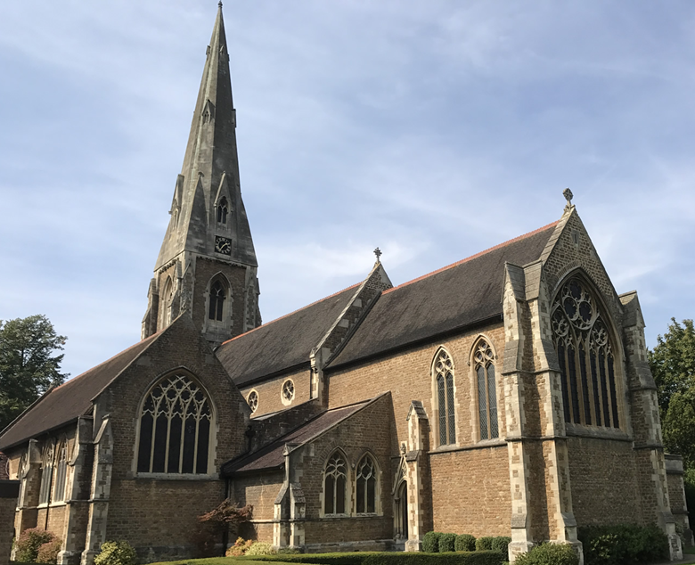

Liberal Catholic Tradition, Anglican and Church of England
St James’ Church is part of the Anglican Communion, the Church of England and the Diocese of Guildford. Our life and worship are rooted in the sacrament of the Eucharist, where bread and wine show the presence of Jesus Christ in the world.
St James’ has a long-standing Catholic, or 'High' tradition within the Church of England, reflecting the history of the church on this site, which was connected with Chertsey Abbey before the Reformation. Our very church building, built in 1848 in mock gothic style speaks of this tradition with a splendid east window and cathedral style. That invaluable heritage continues to shape our love of liturgy, music, sacrament and prayer. Today, we describe ourselves as Liberal or Modern Catholic, combining the richness of this tradition with a contemporary and outward-looking approach to worship and mission.
We are an inclusive, intergenerational community, welcoming people of all ages, backgrounds and stages of faith. We seek to proclaim the Gospel afresh for each generation, creating a church where people can encounter God, grow in faith, discover their gifts and find a sense of belonging. Our life together is shaped by worship and prayer, Christian theology and formation, priesthood, vocation, pastoral care, ecumenism and social justice. We value the contribution of both lay and ordained members and seek to be creative, imaginative and generous in our shared discipleship and mission.
We hold to the great creedal and apostolic doctrines of the Church and value Scripture, interpreted through the wisdom of tradition and reason. Above all, we welcome and serve all people in the name of Jesus Christ. We are proud members of the Inclusive Church network and are committed to ensuring that everyone is valued, included and able to participate fully in our common life and worship www.inclusive-church.org.

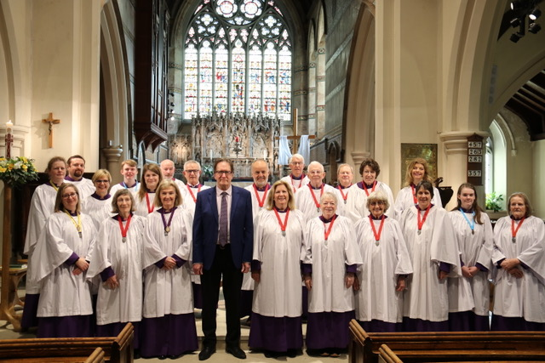

Music at St James’
The choir of St. James’ has a long and distinguished tradition of leading the worship and music-making within the church and takes part in all the main services throughout the church year.
It is a mixed choir comprising between 20 and 30 voices who sing a wide range of repertoire drawn from the 16th century to the present day. An anthem is sung following the administration of Holy Communion at every 10 am Sunday service and Festival and there is a major choral contribution to the many additional services at Eastertide, Christmas and other special festival occasions.
The choir is open to all without voice trial. Choir practices are currently held each Wednesday in the Church from 7.30 pm. The choir is affiliated to the RSCM and uses their published training material. We are always keen to welcome new members.
There are two hymn books in regular use, often alternated week by week: The New English Hymnal and Complete Anglican, Hymns Old and New (orange copy). For special services, Festivals and events we tend to print a service sheet, allowing us to draw from either book or use other resources such as Taizé, chants from various sources and music by Bell, Barrat and Rizza among others. Often, we use one of these pieces on a Sunday morning as a gradual hymn either side of the Gospel, with the text or music printed in the newsletter and would like to further develop this repertoire.

The Sung Eucharist takes place weekly at 10.00 am on Sunday, with a choir rehearsal before from 9.20 am (usually in the Parish Centre). The service is followed by refreshments. In addition, we celebrate the following church Festivals, usually with a Sung Eucharist:
Epiphany, Candlemas, Ash Wednesday, Maundy Thursday, Good Friday, Easter Eve (Vigil or 6 am Easter Day), Easter Sunday, Ascension, Pentecost, Peter and Paul, Patronal, Holy Cross, All Saints, All Souls, Advent Sunday (Christingle), Nine Lessons and Carols, two crib services on Christmas Eve, Midnight Mass, Christmas Day, Civic Services and the Festival of the Blessed Virgin Mary. We also hold up to four choral Evensong services each year. The Director of Music is expected to play at the majority of festivals, unless agreed in advance with the Incumbent.

At St James’ Church we usually require an organist for all Occasional Offices and those holding weddings and funerals in church need to have an organist. The Director of Music has first call for all occasional offices, before we open the request to the larger team of musical support.
Weybridge Parochial Church Council has set four key priorities for the next phase of our Church Development Plan. One of these is to develop a Youth Choir, to sit alongside the existing traditional church choir, and aimed at children and young people aged 11+. There is presently a gap in our church provision for teenagers and young people and we hope, through music to create a new group to thrive for this age group. The new Director of Music will be part of this exciting project, along with the ministry team.
St James’ is proud to own a magnificent two-manual pipe organ conceived in the baroque style and built by Peter Collins of Redbourne in 1983 but re-using John Loughborough Pearson’s casing from the 1880’s. The church also has a Schimmel baby grand piano, and both the organ and the piano are used frequently in services, concerts and recitals for the congregation and the wider community.
The organ is maintained by Sheppard and Cross Pipe Organ Services.

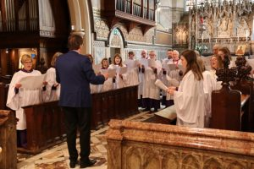

Job Description

Director of Music
Responsible to the Incumbent

The Church takes the safety of everyone within the church very seriously and expects that everyone will work within the church safeguarding policy. In particular, the Church expects anyone who becomes aware of a safeguarding risk or of actual abuse, to immediately report it.

Key Responsibilities

- Ensure that safeguarding policies are adhered to, guidelines are followed, and all safeguarding training is up to date
- To work in accordance with the Diocesan Safeguarding Policy and to report any areas of concern to the Parish Safeguarding Officer and the Incumbent
- Be able to support the values of our church, be comfortable with the inclusive values of St James’ and create a welcoming and sympathetic environment for all
- Ensure the performance and development of music as an integral part of St James’ worship and tradition
- Play the organ, conduct the choir at services and lead the weekly choir practice
- As part of the music committee, share in the task of preparing music appropriate to the liturgical season and readings
- Manage the music library, extending the cataloguing, and arranging to order new music as needed (cost being approved by the Standing Committee)
- Sit on the Liturgy & Ministry Team (meets quarterly)
- Recruit, retain, and train younger choristers and adult singers, develop their skills and encourage a positive culture
- Provide ongoing support, encouragement, and development for choir members
- Oversee and in time develop further a group of musicians who support the musical life and tradition of St James’
- Provide induction for new choir members
- In liaison with the Parish Administrator, maintain a rota for service cover including retired and assistant musicians
- Implement a youth choir and make connections with local music departments at Heathside, Cleves, St George’s and St James’ Schools
- Liaise with parents or guardians of children regarding expectations
- Act as the first contact for any concerns whether voiced by children or parent/guardian
- Develop links with other choristers and musicians in the wider deanery and diocese
- A willingness to learn new skills and develop further as a musician and a leader
- Oversee the maintenance and tuning of the organ and piano and advise the Parochial Church Council on any remedial works required
- Keep updated CCLI and One License returns and copyright permissions/licenses for all music and keep records accordingly

Knowledge/Skills/Abilities

- Demonstrable ability to support the mission of a parish church and the discipleship of church members through its musical life
- Proven ability to lead and train choirs of adults and children with a range of abilities
- Experience and desire to work with children and young people
- An extensive understanding of vocal technique
- A good knowledge of Anglican church music and liturgy
- Familiarity with copyright law applicable to church music
- The ability to work within a team, work collaboratively, and maintain good working relationships with clergy, musicians, and church leadership
- Is an encourager and able to nurture skills in others
- Professional, friendly, empathetic, patient, and approachable, including when under pressure
- Ability to maintain confidential information
- Excellent listening skills
- Able to engage and work with a diverse range of people; some who are/may be vulnerable
- Ability to exercise sound judgment to make solid decisions
- Strong sense of self-awareness
- Organisation, administrative and record-keeping skills appropriate to the responsibilities of the post
- Knowledge and understanding of St James’ vision, policies, procedures and standards
- Knowledge of Copyright & music licensing legislation/requirements and their impact upon a Parish Church would be advisable

Contacts

Internal
- Clergy and church leadership
- Parish office

External
- Contact with the community in the parish
- St James Church of England Primary School
- Other schools and music departments
- Retired and assistant musicians

Safeguarding
St James’ Church Weybridge is committed to safeguarding children, young people, vulnerable adults, and the elderly. All postholders are subject to a satisfactory enhanced DBS (Disclosure and Barring Service) and relevant safer recruitment processes, including the completion of a confidential declaration form and the completion of appropriate safeguarding training on appointment.

Training
The following safeguarding pathways will need to be completed:
- Basic Awareness
- Foundation
- Leadership

Disclosure and Barring Service Check
An enhanced check is required with children’s barred list checks.

Right to Work
It is a condition of any offer of employment we make to you that you have, or gain, permission to work in the UK. By law, you will not be able to start working with us until you are able to provide evidence that this permission has been granted.

Equality, Diversity and Inclusion
At St James’ Church Weybridge, we are committed to work with determination towards a fuller representation of the social, cultural, and ethnic diversity which accurately reflects the people we serve in the parish. We expect all employees to promote and model equality, diversity and inclusion in their working practices and relationships and to uphold principles of equality and opportunity in accordance with our legal obligations.

If you have a disability, long-term illness, or are neurodivergent and you feel that prevents you from meeting any of the essential criteria, please contact us to discuss what reasonable adjustments we can make for you.

At St James’ we are committed to a warm welcome for all. We are proudly part of Inclusive Church and welcome all, as we seek unity amidst our diversity, recognising that we do not all agree on everything, but we seek to disagree well.

Terms of Employment
You will be employed by Weybridge Parochial Church Council. Your line manager will be the Incumbent. This is a permanent position and is subject to a probationary period of six months.

The salary for the position is paid monthly in arrears. Fees for Occasional Offices such as Weddings, Funerals and Memorial services are claimed monthly for each service undertaken, with a double fee for services where a video is made, in accordance with RSCM guidelines.

Aside from scheduled services, practices (and occasional offices), there are no set working hours. Administrative duties may be completed at home, in church or the ‘hot desk’ in the Parish Office, and at times to suit your needs. Overall, we expect the work (services, practices, and admin work) to take an average of 5 hours per week. During busy periods this may be more, but there will equally be quieter periods, for example during August when regular choir practices don’t take place and there’s minimal work to complete.

The salary is reviewed annually. Based on previous years, salaries at St James’ have generally risen in line with inflation.

You will be enrolled in the government NEST pension scheme. Full details will be made available with your contract of employment.

You will be entitled to receive 6 working weeks of holiday, including 6 Sundays. There may be a requirement to work on a bank holiday. Time off in lieu will be given.

You will have regular meetings with the Incumbent and an annual appraisal, as well as attend the bi-monthly music committee which, with you will chose the music for Sundays and Festivals to fit the set Lectionary bible readings and seasonal themes. You are also invited to attend the quarterly meeting of the Liturgy & Ministry Team, a sub-committee of the PCC.

Attending relevant professional development training is encouraged and supported.

Following the successful completion of your probationary period, your period of notice is three months.

Full details of remuneration and fees applicable will be made available to short-listed candidates.

Application Process
If you would like an informal conversation prior to making your application, please contact Fr Damian Harrison-Miles by email at rector@stjamesweybridge.org.uk.

To apply, please send your CV, including two referees (of which one must be professional) who we will contact before making an employment offer – and a brief covering letter to Donna Miller, PCC Secretary at pccsecretary@stjamesweybridge.org.uk. All applications will be acknowledged.

Closing Date
The closing date for applications is 9.00 AM on 2 November 2026. Short-listed candidates will be contacted within the week. Interviews will begin Wednesday evening 11 November with choir practice. Face-to-face interviews will take place on Thursday 12 November. Please let us know in your application if the dates work for you.

Our interview process will be as relaxed as possible. We will give you the opportunity to demonstrate your capabilities while providing both you and St James’ with the information to make an appropriate decision. The interview will be led by the Incumbent, alongside two other members of the appointment committee. The interview will also include rehearsing the choir. You will be asked to play a piece of your choice, direct an anthem from a short list and a pre-selected hymn, How Shall I Sing that Majesty, set to Coe Fenn. Full details of the interview process will be sent to pre-selected candidates.

