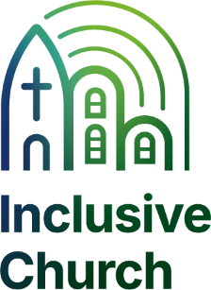
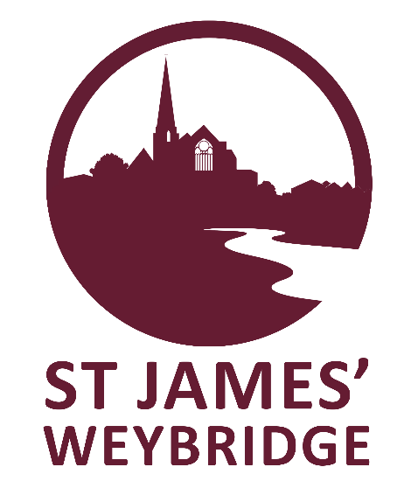
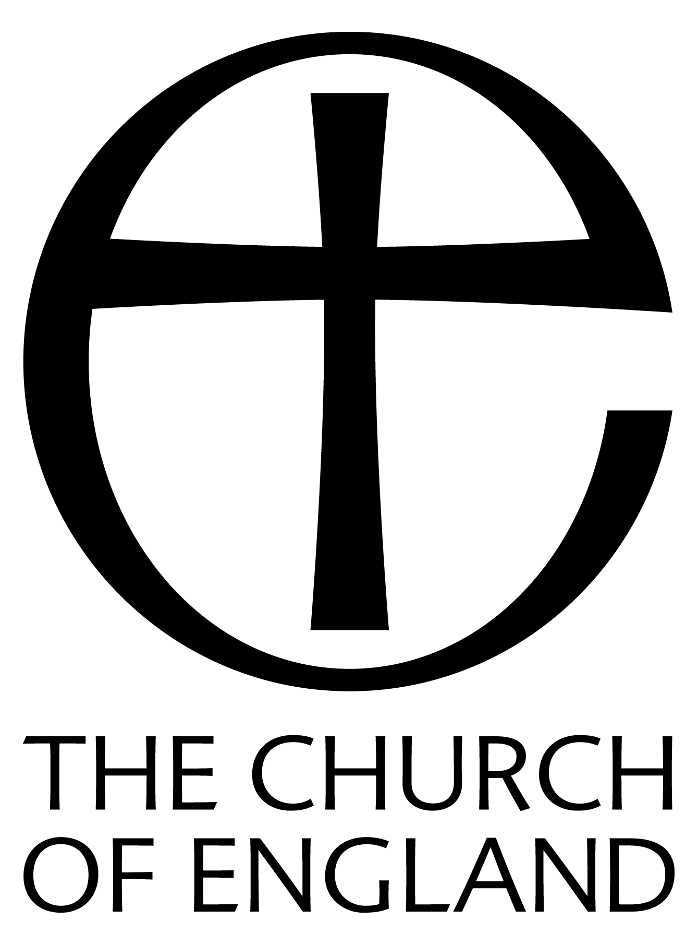
Junior Church – Every 1st, 3rd, 4th & 5th Sunday of term-time
This is Sunday School with a difference, for children between the ages of 4 & 12 years old, and takes place in the small hall of the Parish Centre (next door to St James’ Church) at 10am including craft, songs, bible story and prayers.
Creche The creche, for babies and children up to the age of three, is organised alongside Junior Church.

Family Service
Every 2nd Sunday of the month
11am refreshments served in the Parish Centre
11.30am - 12pm Service

A fun service of children’s songs, a bible reading and story with interactive talk, prayers & craft.

The Ark
BABIES, TODDLER & PRE-SCHOOL GROUP (£2 per child)
MONDAY 9:15 - 11.15am
We meet in St James’ Church. The Ark is a breakfast toddler group for babies, toddlers and pre-school children with parents/carers, including song/story time, play and refreshments including toast! Come along for breakfast and join in the fun.

For Families & Children
The Ark Dates 2026
5th January – 23rd March, 13th April – 13th July,
7th September – 14th December.
No Ark on Monday 16th February, 30th March, 6th April, 4th & 25th May, 20th & 27th July, All of August, 26th October, 21st & 28th December.

Parish Office: 01932 856399 Website: www.stjamesweybridge.org.uk

